CR- 05 All the data should be visible to all MLI User ID’s:
Currently, all the data uploaded MLI Maker/Checker IDs is not available to new Maker/Checker IDs (Records and Invoices etc.)

Requirement:
Portfolios wise all the data uploaded by respective MLIs should be visible to all user ID’s irrespective of old/New User IDs of that MLI. Only visibility should be available.

Note : If MLI upload same loan AC / same file same , there is issue of summation of sanction amount

Input file management
Data uploaded by 1st MLI visible to 2nd MLI without action button

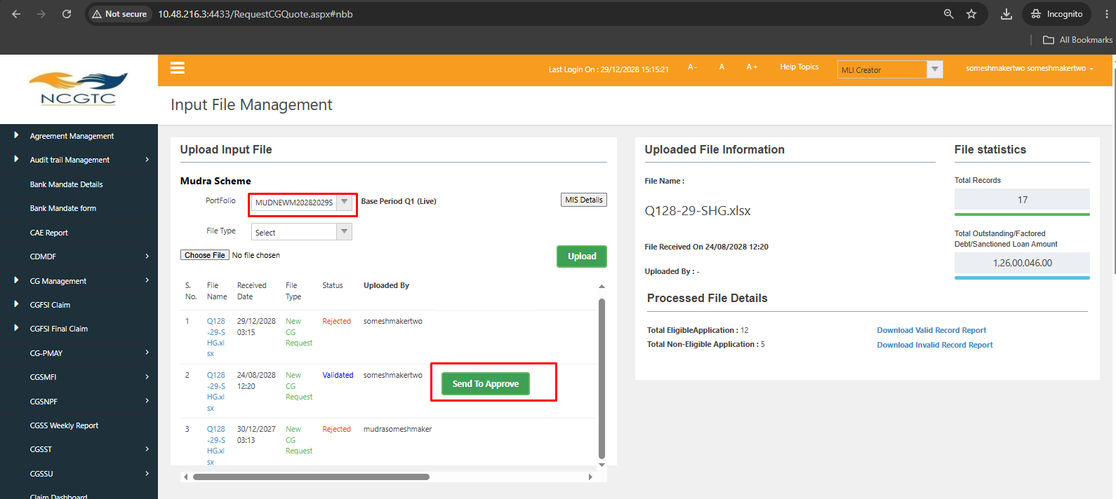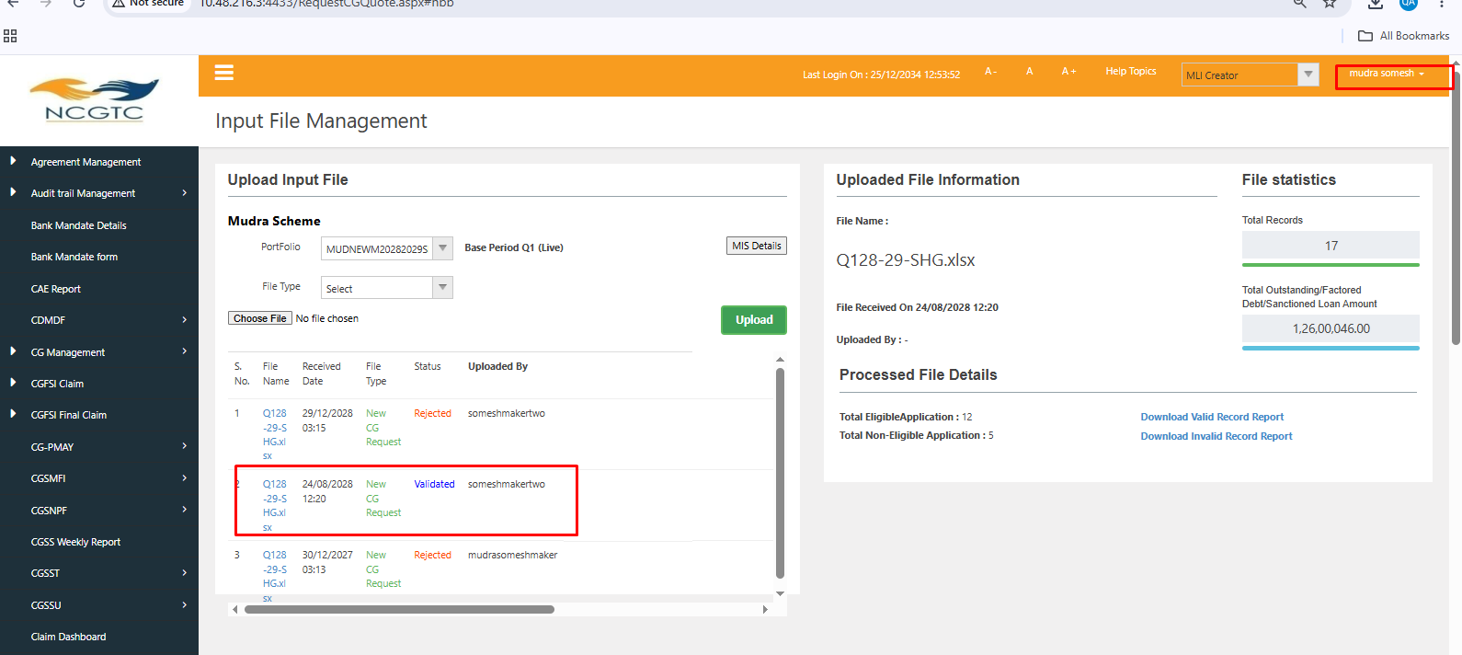

Added MLI name by which file is uploaded and access valid / invalid file
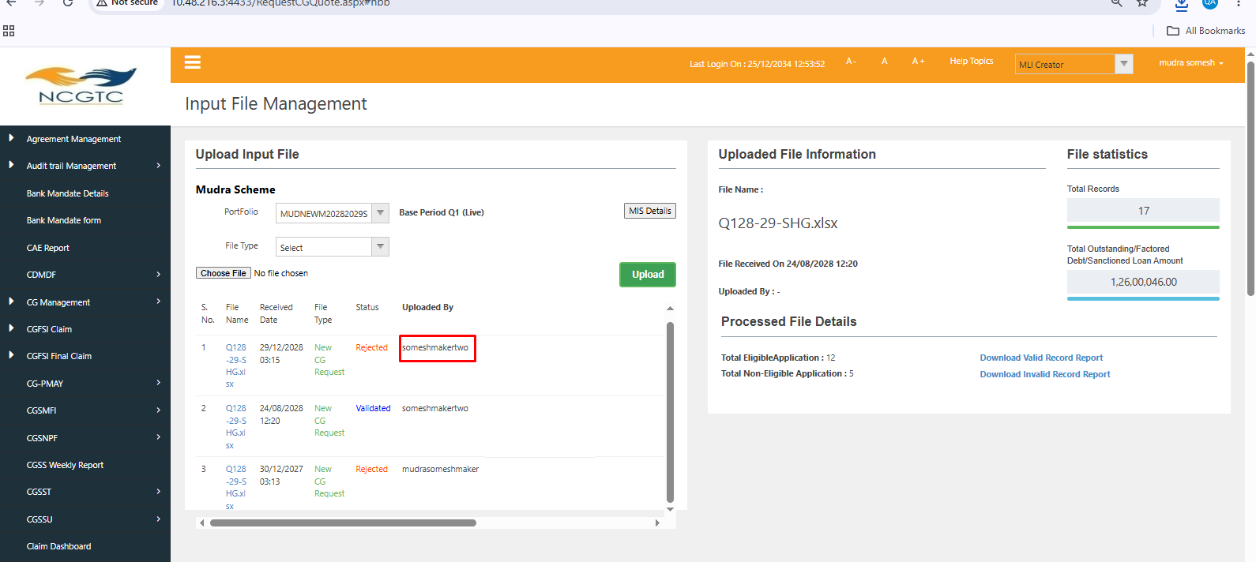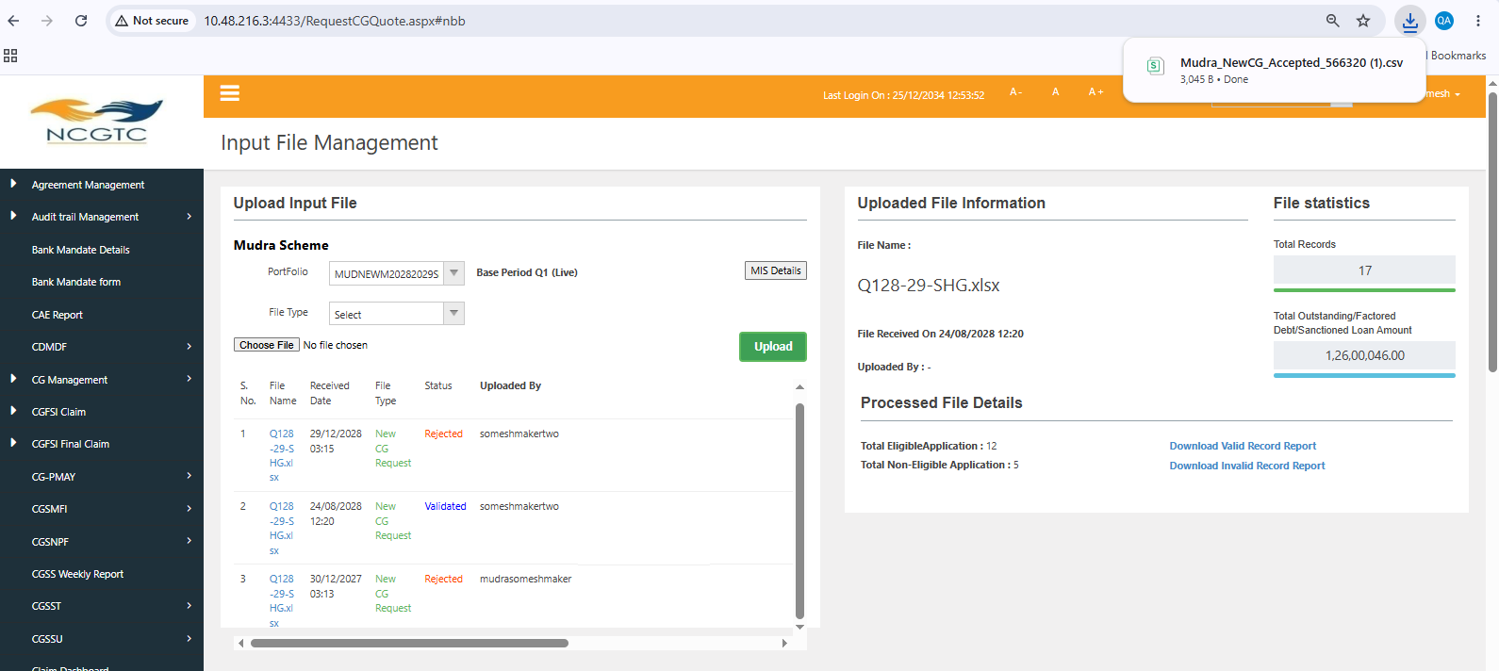

Able to download MIS report
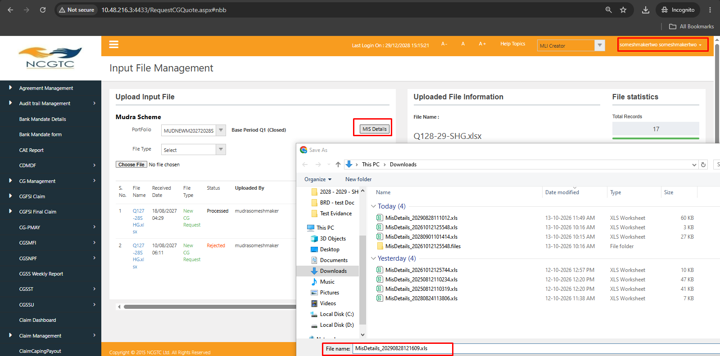

Able to generate bill with both new and old user

